
caMOD – Cancer Models Database

Software Design Description

Release 2.1 – User Search Result Settings

caMOD Team:

Srini Guruswami

David George

Ajay Gupta

Ulrike Wagner

Sima Pandya

Nicholas J Schroedl

Marc Piparo


Document Change Record
Version Number | Date | Description
1.0 | 03/08/06 | Initial document
1.1 | 5/01/06 | Revisions and screen shots

TABLE OF CONTENTS
1. Introduction 1
1.1 PROJECT BACKGROUND 1
1.2 SYSTEM OVERVIEW 1
1.3 Requirements Traceability 2
1.3.1 Relevant Statement of Work Tasks 2
1.3.2 Functional and Technical Requirements 2
2. Use Cases 3
2.1.1 New Use Case 3
3. Components 9
3.1 USER INTERFACE 9
3.1.1 Navigation Bar 10
3.1.2 Customize Search Results Page 10
3.1.3 Search Results Page 11
3.3 MIDDLE TIER 15
3.3.1 ResultSettingsManager 15
3.4 BACK END 15
3.4.2 Domain Classes 16
3.4.3 Database Design 17

Introduction
The purpose of this document is to describe the design for saving user’s queries and search history for future editing and use. This is being developed for Release 2.1 of caMOD. This document identifies and defines the requirements for various user requests for the caMod application

Background/summary
The cancer models database (caMOD) is a web-based resource that provides information about rodent models for human cancer to the public research community.
caMOD provides the following key capabilities to its users:

- Data Submission--Data in caMOD are extracted from the public scientific literature by curators and verified by the scientists who generated or worked with the models, or they are directly submitted by scientists.

- Cancer Model Search--Users can retrieve information about the making of models, their genetic descriptions, histopathology, derived cell lines, associated images, carcinogenic interventions, microarray data, and therapeutic trials in which the models were used. caMOD provides links to PubMed for associated publications and other resources such as mouse repositories, detailed information about altered gene, pathway affected, and information about human clinical trials that utilize the same compounds as the pre-clinical trials in the animal models.

- System Function Administration--The Admin function provides services for user registration, review of submitted models and database management.

Requirements Traceability

Relevant Statement of Work Tasks
The caMOD Cancer Models Database Statement of Work (SOW) Task Description contains the following items that will be implemented as part of this design:
1. Develop a user preferences function that allows users to save settings concerning search results. This involves:

  - User selects up to five columns for displaying search result details.
  - User selects how many search results to display per page.

Functional and Technical Requirements
The following is a more detailed list of requirements for this enhancement:
ID | Requirement
1 | Allow users to specify which columns to be displayed on search result page
2 | Allow users to set the number of search results to displayed per page
3 | Allow users to save and edit these settings

Use Cases
User preferences requirements were documented by a combination of adding new use cases and updating existing use cases.

New Use Case

Save Search Result Settings Use Case

Use Case Name | Save Search Result Settings Use Case
Use Case ID | 1
Primary Actor | Researcher (User)
Trigger | User wants to save their search result settings for future use.
Pre-conditions | User is logged in and has clicked on the Customize Results.
Flow of Events | 1. User selects one or more columns from the available columns list.  2. User presses the “>” arrow icon, to move the selected items to the selected items list.  3. User selects the number of Items per page from the dropdown.  3. User presses the Save button.
Post-Conditions | Success Condition: The selected columns and number of items per page are saved for the user. The user is directed to the simple search page.  Error Condition: Too many columns selected. Print error message.  Error Condition: Model Descriptor is not selected. Print error message.
Alternative Flow

Components

USER INTERFACE

Navigation Bar
Link will be provided in the left side navigation to give the user access to the Customize Results page. The links are accessible to all users and appear as follows:
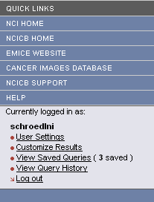

Customize Search Results Page
The Customize Search Results page will allow users to which columns they want to see on the search result pages as well as how many search results to display per page. WThe fields will look as follows:
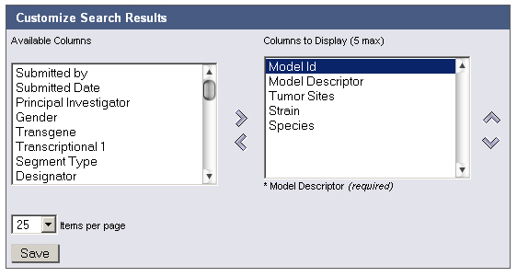
Message Type | Message
Error | Too many columns to display.
Error | Model Descriptor is a required field.

Search Results Page
The search results page has changed to display the selected columns. If the user has no custom setting the default columns ( Model Descriptor, Tumor Sites, Species ) will be used. The number of items displayed many change depending on what the user has selected. Also, each column is sort able by clicking the column header. The page displays a table of all queries that are currently saved for the user and appears as follows:

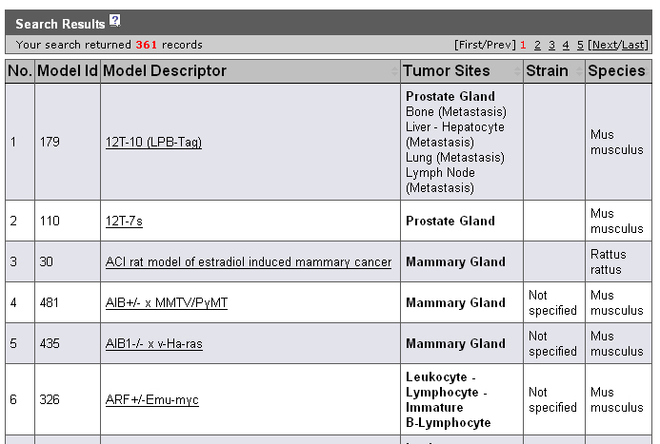

MIDDLE TIER

ResultSettingsManager
ResultSettingsManager is a new class that manages persistence for user settings. Its methods will be:
Method Name | Description
save | - Creates a ResultSettings domain object.  Creates a ResultSettingsColumns domain object for each non-transient column selected and adds them as children of the ResultSettings domain object.
remove | Removes the ResultSettings object by id.
get | Retrieves ResultSettings object by id.
getByUsername | Retrieves ResultSettings object by username.
update | Updates the values of the ResultSettings object.

Domain Classes

ResultSettings
Attribute Name | Attribute Type | Description
id | Integer | Primary key (system generated)
User | many-to-one association to PARTY_ID | Reference to the user that saved the query
resultSettingsColumns | One-to-many association to ResultSettingsColumns | List of columns that the user has selected.
itemsPerPage | Integer | Number of search results to display per page.

ResultSettingsColumns
Description: Child of ResultSettings. Represents the criteria for a ResultSettingsColumns record.
Attribute Name | Attribute Type | Description
id | Integer | Primary key (system generated)
columnName | String | Value chosen by the user for the column.
parentResultSettings | Many-to-one association to ResultSettings | Association to parent

Database Design

RESULT_SETTINGS
Table: RESULT_SETTINGS
Column Name | Column Type | Class / Attribute Name
RESULT_SETTINGS_ID | NUMBER | ResultSettings.Id
PARTY_ID | NUMBER | ResultSettings.User
ITEMS_PER_PAGE | NUMBER | ResultSettings.itemsPerPage
COLUMNS_TO_DISPLAY | VARCHAR2(300) | ResultSettings.columnsToDisplay

RESULT_SETTINGS_COLUMNS
Table: RESULT_SETTINGS_COLUMNS
Column Name | Column Type | Class / Attribute Name
RESULT_SETTINGS_COLUMNS_ID | NUMBER | ResultSettings.id
COLUMN_NAME | VARCHAR2(300) | ResultSettings.columnName
RESULT_SETTINGS_ID | NUMBER | ResultSettings.resultSettingsId

